Jayanthi

**Assignment 28/10**

Create a multi-stage Dockerfile for a Node.js app, where one stage installs dependencies and the second stage builds the app.

Compare the size of the final image with and without multi-stage builds.

Step 1: clone the repo from github which consist of simple node.js app

<https://github.com/jayanthis952/simple-nodejs-app_multistage_build.git>

git clone <https://github.com/jayanthis952/simple-nodejs-app_multistage_build.git>

cd simple-nodejs-app

create a dockerfile

vi Dockerfilewtm

FROM node:18

WORKDIR /app

COPY package*.json ./

RUN npm install

COPY . .

EXPOSE 3000

CMD ["npm", "start"]

Run the application using below command

**docker build -f Dockerfilewtm -t my_ubuntu:latest .**

And run the application container using below command

**docker run -it -d -p 3000:3000 my_ubuntu:latest**

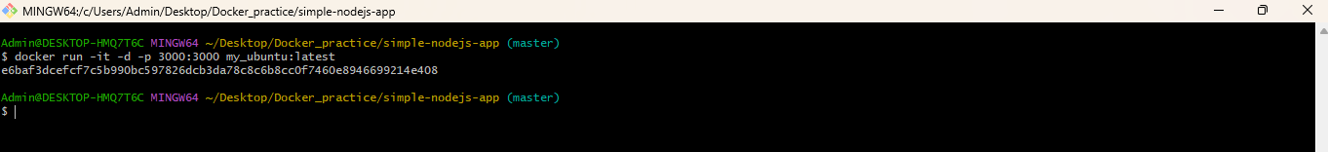

Check the image size using below command

**docker images**

**Write a multistage docker file using multiple FROM (base image)**

**vi Dockerfile**

FROM node:18 AS build

WORKDIR /app

COPY package*.json ./

RUN npm install

COPY . .

FROM node:18-alpine AS production

WORKDIR /app

COPY --from=build /app /app

EXPOSE 3000

CMD ["npm", "start"]

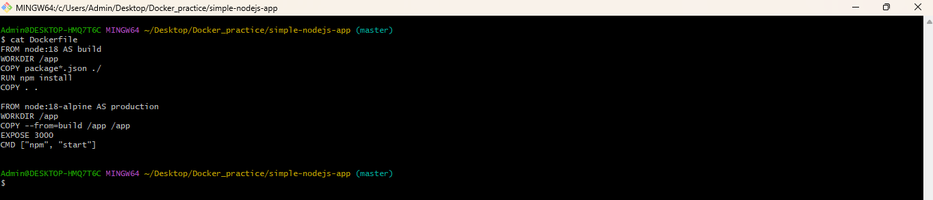

Build the image with multistage docker file using below command

**docker build -t my_ubuntu:latest .**

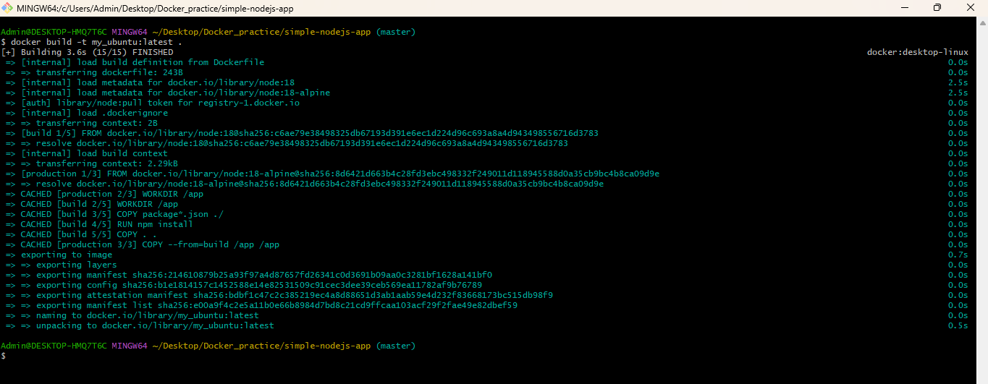

Run the container using below command

**docker run -it -d -p 3000:3000 my_ubuntu:latest**

Now we need to check the size of the image using below command

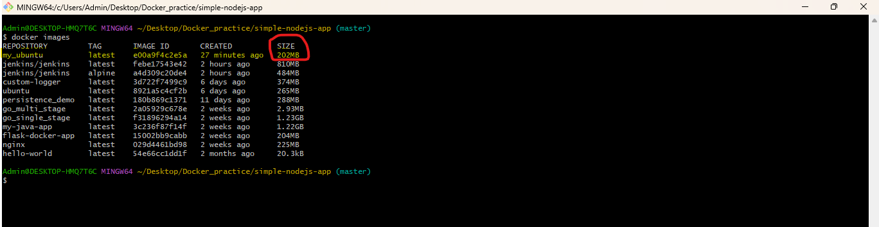

Size is reduced from **1.6GB to 202MB**

**We can able to access the port from outside using below url**

[**http://localhost:3000/**](http://localhost:3000/)

